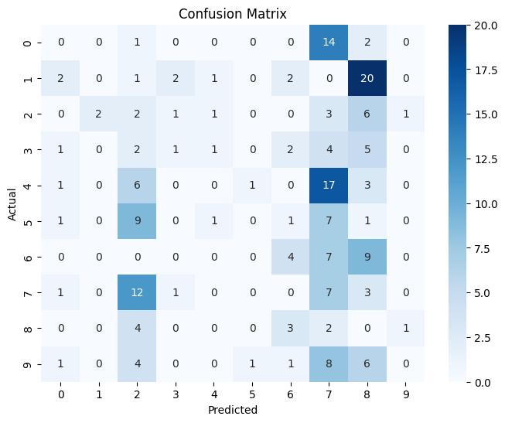**Put Your Code Results Here:**

**precision recall f1-score support**

**0 0.00 0.00 0.00 17**

**1 0.00 0.00 0.00 28**

**2 0.05 0.12 0.07 16**

**3 0.20 0.06 0.10 16**

**4 0.00 0.00 0.00 28**

**5 0.00 0.00 0.00 20**

**6 0.31 0.20 0.24 20**

**7 0.10 0.29 0.15 24**

**8 0.00 0.00 0.00 10**

**9 0.00 0.00 0.00 21**

**accuracy 0.07 200**

**macro avg 0.07 0.07 0.06 200**

**weighted avg 0.06 0.07 0.06 200**

1. **Explain how you designed your model (number of layers, neurons, and activation functions).**

**What changes did you make to improve the accuracy, and how did those changes affect the results?**

*Please attach the performance results before and after your improvements.

**2. Based on your evaluation results (confusion matrix, ROC, etc.), how well did the model perform? Which classes are harder to predict? Why do you think that happened?**